**California State University Sacramento**

**Electrical and Computer Science Department**

**EEE 193B/CPE 191 - Product Design Project II**

**Final Project Report**

**Craft Cube**

**2 in 1 CNC machine**



**Team Member:** Ammar Ahmed/Thomas Bock/Tan Hua/ Michael Golez

**INSTRUCTOR:** Suresh Vadhva

***Abstract***

#TODO (Mike): Update abstract

Our goal was to create a low cost CNC laser cutter/engraver that was meant for use at the hobby, educational, and small project level. It is built with inexpensive and 3D printed parts that are available online. It includes a camera system to aide in the design process. It is able to cut materials up to the size of a standard 8.5x11“ piece of paper. The types of material that the machine can cut/engrave include:

* Paper
* Wood
* Cardboard
* Craft Foam

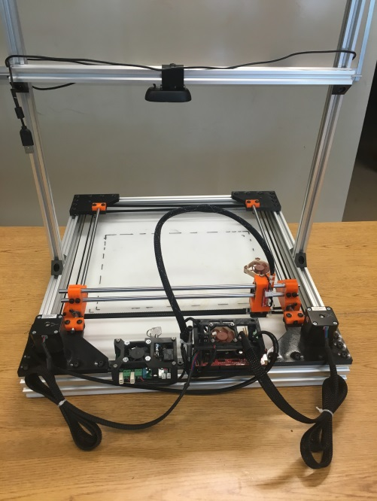

#TODO (Tan or Ammar or Tom): Update the Content Table

Contents

I. Design Overview 5

A. Introduction 5

B. Equipment List 6

1. Mechanics 6

2. Laser System 6

3. Software 7

4. Computer Vision 7

C. Team Member Summary 7

D. Detailed Description 8

1. Mechanics 8

2. Laser System 11

3. Software 11

4. Computer Vision 12

II. Proposal 15

A. Funding and Cost 15

1. Mechanics 15

2. Laser System 16

3. Software 16

4. Computer Vision 17

B. Product Proposal 17

III. Work Breakdown Structure (WBS) 17

A. Outline of WBS 17

1. Mechanics 19

2. Laser Diode 19

3. Software 19

4. Computer Vision 19

B. Project Timeline 19

1. Milestone 1 20

2. Milestone 2 20

3. Milestone 3 20

IV. Risk Assessment 20

A. Laser Emission Hazard 20

B. Smoke Hazard 20

C. Fire Hazard 21

V. User Manual 21

A. Safety Requirement 21

B. Hardware Requirement 21

C. Software Requirement 21

D. Operation 21

VI. Design Documentation 24

A. Hardware Subsystems 24

1. Camera 24

2. Laser Diode 25

3. Microcontroller and Shield 27

4. Block Diagram 28

B. Software Subsystems 28

1. Object Detection Algorithm 28

2. Design and G-Code Generator 28

3. Stepper Motor and Laser Control 28

4. Flowchart 29

VII. Test Plan 29

A. Hardware 29

1. 3D Printed Parts 29

2. Linear Motion Parts 30

3. Frame 30

4. Assembly 30

5. Laser 30

B. Software 30

1. Microcontroller Test 30

2. Software Test 30

3. Computer Vision 31

C. Integration 31

VIII. Accomplishment and Improvement Ideas 31

A. Accomplishment 31

B. Improvement Ideas 31

IX. Conclusion 32

X. Appendix A: Reference 32

XI. Appendix B: 32

A. Project Timeline 32

B. Code 33

# Design Overview

## Introduction

#TODO (Tom): Update introduction with new description, equipment list

All around the world there are different tools that are used to create or modify an object in order for certain materials to be applicable and used by humans everywhere. Types of device that is used by industry and commercialize companies include a laser cutter/engraving machine and 3D printers. Some applicable uses that machines have displayed over the years include Architectural models, labs and educational settings, and displays and gadgets. By possessing these machines and instrumenting a localized floorplan of its construction, a user can efficiently create objects of interest that can provide necessity.

Our Project, the Craft Cube, integrated both machines: Laser cutter/engraver and 3D printer in one single machine. We focused on making the craft cube a user friendly machine and adding more features to enhance the operation of the machine.

The Laser engraver/cutter operates through the use of a high-energy infra-red laser light beam. By implementing a focusing lens towards the laser diode, the light beam is concentrated into a single focal point. The focal point allows maximum melting and vaporization of the desired material of interest.

The 3D printer operates XXXXXXXXXXXXXXXXXXXXXXXXXXXXXXXXXXXX

XXXXXXXXXXXXXXXXXXXXXXXXXXXXXXXXXXXXXXXXXXXXXXXXXXXXXXXXXXXXXXXXXXXXXXXXXXXXXXXXXXXXXXXXXXXXXXXXXXXXXXXXXXXXXXXXXXXXXXXXXXXXXXXXXXXXXXXXXXXX.

In order to alter the position of the laser into a desired location, a computer program known as CNC drives the positon of both the x and y axes. Asides the orientation of the axes, CNC codes can adjust the intensity of the laser to enhance the engraving or cutting of the material. Finally, by using machine vision, we can determine the position of the object relatively to the workspace through the process of object orientation. This process allows finer cutting and engraving for better result. The construction and programming of the CNC Laser Machine will be conducted into four different parts: the mechanics will handle the positions of the CORE X-Y axes, the Laser Diode will generate the light beam for the cutting and engraving, the CNC software will allow for control and intensity of the overall system, and finally detection system will detect the workspace for maximum efficiency.

## Equipment List

### Mechanics

* + - Stepper Motor (2x):
    - Belts(2x)
    - Linear Rods(4x)
    - Linear Bearings(6x)
    - LED strip(1x)
    - Aluminum Extrusions(7x)
    - 3D Printed Parts:
    - X-Y Carriages()
    - Toolhead()
    - Linear Rail Mounts()

### Laser System

* + - Laser Diode: 2W 445nm M140 Blue Diode in Copper Module W/Leads
    - Laser Lenses:405-G-2 Glass Lens for Aixiz Laser Module 405nm 445nm
    - Laser Driver:
      * 1.8 X-Drive V6 Laser Driver-M140-PLTB450-PLTB450B-NDG700-NDG7475
      * 12V TTL 200mW to 3W 445nm 450nm Laser Diode LD Power Supply Driver
      * 2.5 Amp Adjustable Safety Compliant Laser Diode Driver Kit, for UV-Blue diodes, with International Power Adapter

### Software

* Arduino Mega with a RAMPS 1.4 motor shield
* ACE 2510S 5V Cooler Brushless DC Fan 25*10mm Mini Cooling Radiator(2x)
* Meanwell Style Power Supply(12V 30A)

### Computer Vision

* Camera (x1): RaspberryPi Module V2

## Team Member Summary (#TODO (Ammar)= Updated)

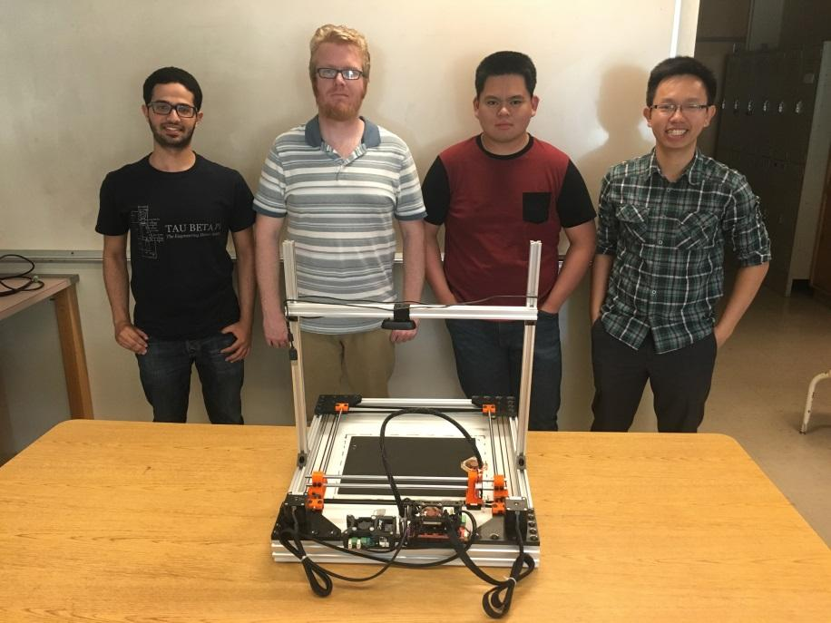

**Team Members**

From left to right: Ammar Ahmed, Thomas Bock, Michael Golez,

Tan Hua

**Ammar Ahmed -** Ammar is a senior, majoring in Electrical Engineering at Sacramento State University. His focus is in control systems with a small emphasis in Analog IC Design. His contribution towards the project was the development of the computer vision system. This system was implemented on OpenCV-Python to get the dimension and location of the object in the working space. Currently, he is a member of the Hornet Hyperloop club. Also, he is a tutor at the Math department at CSUS.

**Thomas Bock -** Thomas is a second semester senior majoring in Electrical Engineering at Sacramento State, with a focus on control systems. His contribution to the project was the design and construction of the frame and linear motion system of the Craft Cube. This system allows for accurate and reliable motion of the end effector.

**Michael Golez -** Michael is a senior engineer at California State University, Sacramento, majoring in Electrical Engineering. His primary focus is Digital/Analog Systems with a small emphasis in Control Theory. In the design of the CNC laser system, his contributions include the powering and operation of the laser diode and laser control circuitry. This involved designing and implementing a constant current source that can operate the laser safely.

**Tan Hua -** an is a Communication System Engineer with a minor focus on Digital Signal Processing. Over the years at Sacramento State, he spent time practicing software development. Currently he is working as an I.T. support for the state. As a result, his main focus towards the project would be the software implementation towards controlling the CNC laser system.

## Detailed Description

In order to design the CNC laser cutter and engraver, research was made on the components needed to build the system. After spending a good amount of time researching and reading about specifications and features included in other CNC laser cutter machines, the team had a brainstorming meetings to come up with new features to make a better product. Our approach was to add more features to make the design simpler and enhance the interface and operation of the device. The following sections discuss the four main parts that the team focused in order to design the product:

### Mechanics

The mechanics of the laser system are based on a Core-XY or H-bot motion theory. This theory, popularized by Ilan Moyer, a graduate of MIT, is a cartesian based motion system that relies on two motors with opposing belt paths and mounts to create a simple, fast, and light motion platform. A design illustration of the motion system is shown below.

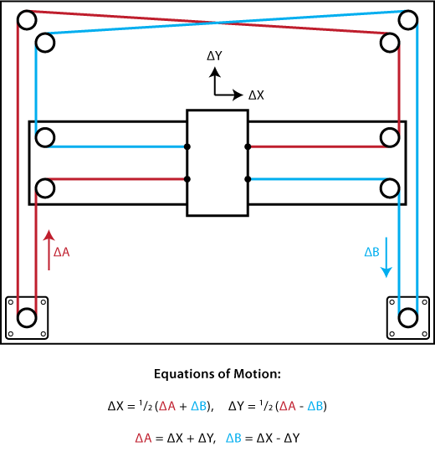

Figure

From the top-down illustration we can see the stationary motors and the belt paths and mounting. Motor A’s belt path is in red while motor B’s belt path is in blue. The red belt path is attached at the lower left of the center tool head, wraps around the motor pulley, up around two other pulleys, then is attached at the top right of the tool head. The blue belt path is a mirror to the red path, mounting at the lower right and top left of the center tool head. Note that the belts cross at the upper middle of the illustration. To allow this crossing, one of the belt paths must be offset in the z axis from the other, which was accounted for in our design. Now some of the key benefits of this design are simplicity, lightweight toolhead, and accuracy. The simplicity is achieved through the use of stationary motors and clever belt routing, which keeps the linear motion parts at the same amount or less, as other cartesian designs. The benefit of a lightweight toolhead is also due to the stationary motors. Mant cartesian style motion platforms mount at least one of the motors on either the x or y axis carriage. The motors are heavy, and can cause issues with binding or backlash due to the excess weight of the toolhead. The accuracy is improved based on the lightness of the toolhead and the minimal backlash in the system. Now after talking about why we chose this design, I can talk about how the mechanics were designed and built.

For the design I used Autodesk Fusion 360. This software is free to use if you sign up with a student account, which is what I did. I had only used CAD software before very briefly to design small parts for 3d printing, and had never used the software to build an assembly of parts. The software took a couple weeks to get familiar with to be able to design parts that would work for the machine. I modeled the linear rails, bearings, motors, and frame pieces first, then designed the other parts to fit the bought parts that would not be modified. The parts that were designed ( and their colors in the model) include:

* Four corner frame pieces (black)
* Four mounting brackets for the linear rods (red)
* Two carriage pieces (red)
* One toolhead(Silver)

The final design of the laser cutter assembly can be seen below. This took into account the belt routing and the size of the nuts and bolts that were going to be used, even though they are not shown.

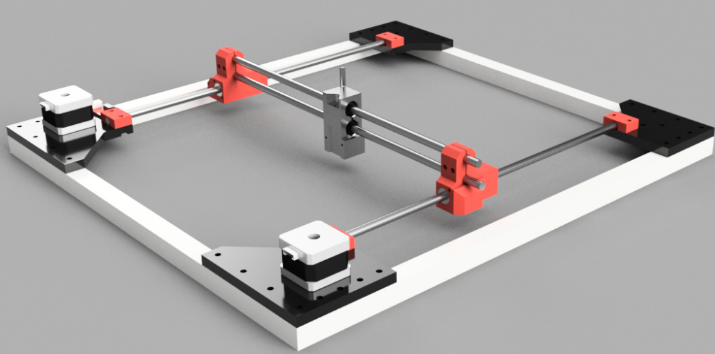

Figure

After the design was finished on the computer, the pieces created in the design had to be 3d printed. I have a 3d printer at home so I printed out the parts and assembled the frame. A couple of the pieces had to be slightly modified to fit which was updated in the design and the parts were reprinted.

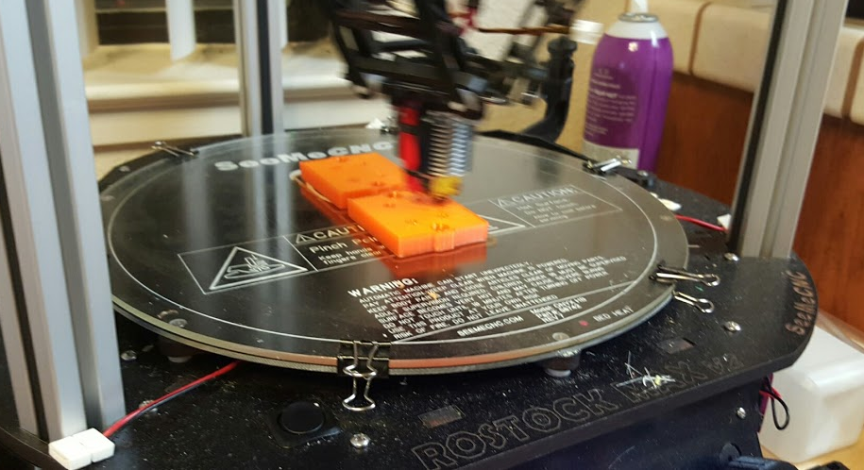

Figure

The final design of the assembled mechanics are seen below in the following image. After this design was completed, I had to design a camera mount for the webcam and that is seen in the finished laser cutter.

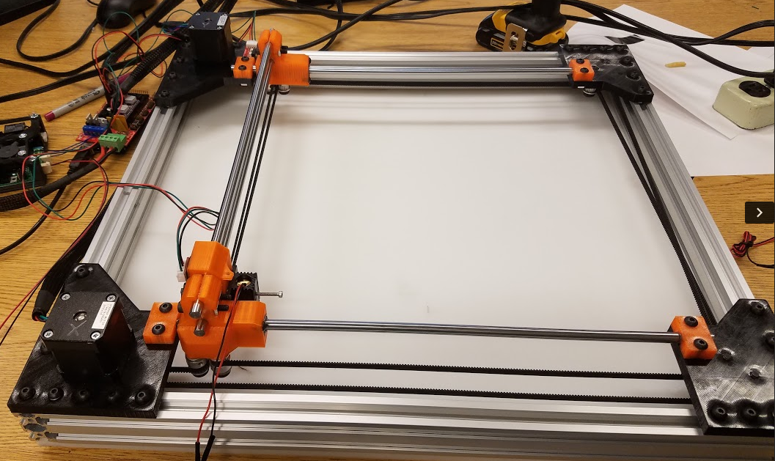

Figure

### Laser System

**Objective:**

Design low power, compact, and easy-to-use laser system.

**Components:**

* 445nm 2W Blue Laser Diode
* 2.5 Amp Adjustable Safety Compliant Laser Diode Driver Kit
* 12V Power Adaptor(8 Volts at a max load of 2A)

### Software

**Objective:**

The purpose of software in this project is to control the process of the machine including cutting and engraving.

**Detailed process**

* **Computer Aide Design (CAD)**

In this step, we can place our desired design such as an image, a drawing, etc. into Inkscape, a computer aided design tool is commonly used for CNC machine. This step helps the user determine how the physical object will look like after cutting or engraving

* **Computer Aided Manufacturing (CAM)**

The purpose of this step is to generate G-code instruction from the design we have from step 1. G-code is a commonly used industrial standard language to control automated machine tool. By using our written plugin called Q-Laser Plugin along with Inkscape, G-code instruction will be generated with stepper motors movement along with laser intensity.

* **Execution**

In this step, G-code instruction that is generated in step 2, now in text file type, will be placed in Repetier Host, a software used to perform G-code instruction along with providing preview and estimated time of executing time. After hitting print, the machine will start running and executing on the physical object until it completes.

### Computer Vision

**Objective:**

* To determine the location of the object in the working space with reference to the laser starting point.
* To get the dimension of the object to ensure that the cutting/engraving process stays within the boundaries of the object.

**Detailed Process**

* RaspberryPi camera module V.2 was used as a sensor to accomplish our goal. The camera was mounted on top and parallel to the working space to ensure correct readings and for calibration purpose. The following are the detailed steps for the running the computer vision and the details for the image processing.

**RaspberryPi 3:**

* The process starts with taking a snapshot from the touchscreen which is connected to the RPi3.

**OpenCV-Python**

* In this step, the algorithm for the object detection will be executed internally on the RPi3 once its given the instruction and the final result will be displayed on the screen. The algorithm runs on OpenCV-python and the following are the steps needed for image processing in order to get the location and dimension of the object in the working space.
  + 1. First step in the code, image is captured that shows the actual object in the working space as shown in the figure below.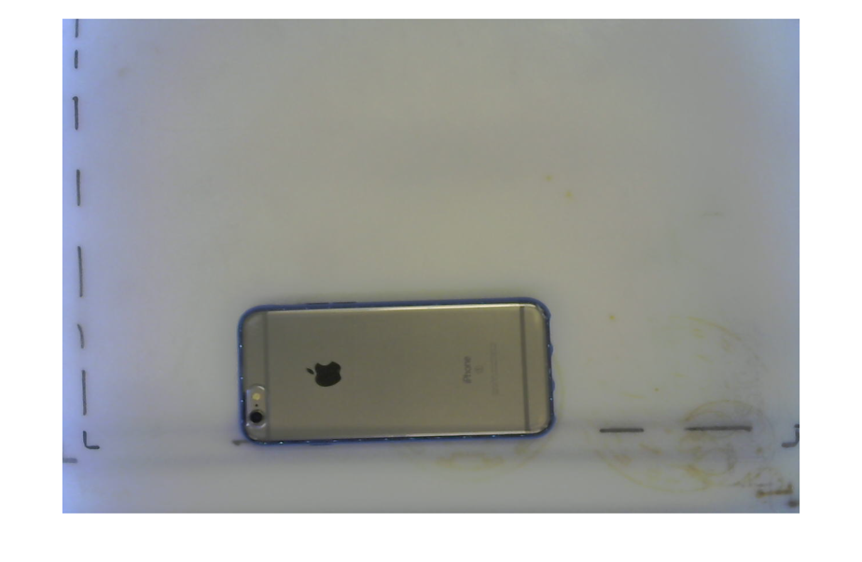

Figure

* + 1. The second step is converting this image into a binary image (black and white). This is done by setting a threshold value to the image conversion. Threshold value is used to set pixels on the image to black if the image intensity is less than the specified value and sets other pixels to white. The result is shown in the figure below.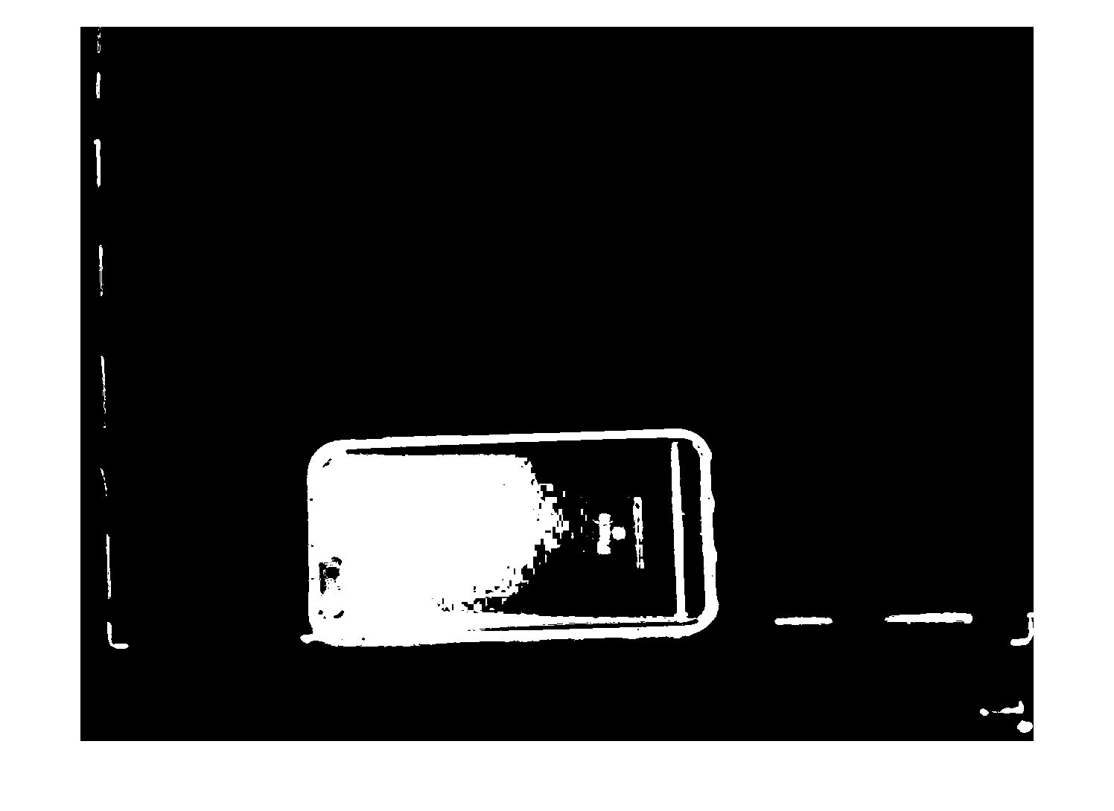

Figure

* + 1. However, the picture has noise in the background which cause an error when running the code. Therefore, filter is applied to remove noise from the background to solve this issue. Another issue in the figure above is that the picture is not filled i.e the rectangular box (which represent the phone) is half black and half white. For this reason, Morphological operation (dilate) is applied to the image to fill out the gaps which enhance the quality of the binary image as shown in the figure below. 

Figure

* + 1. Lastly, it is easier now to detect the object and bounding box is applied to the image. Bounding box is an algorithm that detects white pixels in an image and draws a box around it. This helps in getting the size of the box and the location in pixel. These numbers will then be multiplied by a calibration factor to convert the pixel to real world unit “cm”. The figure below shows the final results for the image processing. At the bottom on the left half side of the figure below is the actual dimension in cm. The right side shows the object been detected and a red box (Bounding Box) is drawn around the object.

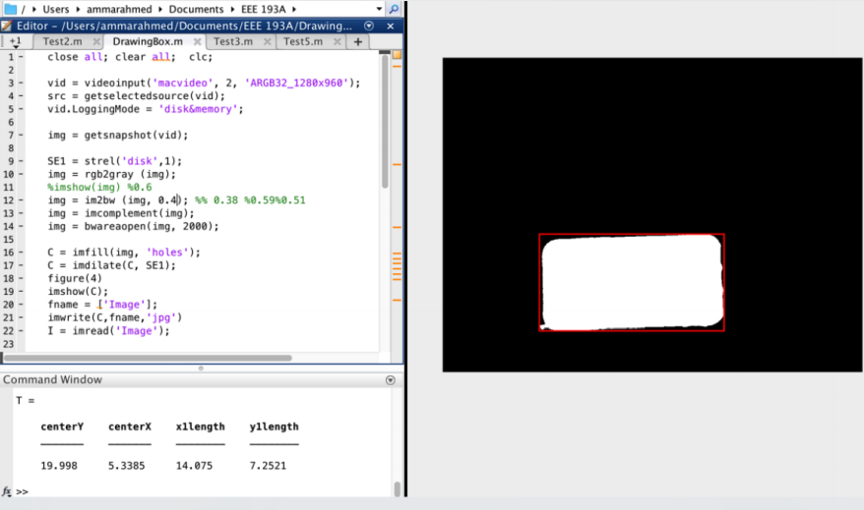

Figure

# Proposal (#TODO (TOM))

## Funding and Cost

In reference to finding allocated funds for the production of the Laser Cutter/Engraver, each individual member proposed a draft meeting to discuss the funds needed for the production of the CNC laser system. The desired funds for the 1st semester prototype were expected to be about $1000 and $500 for the second semester. Because the mechanical and hardware aspect of the project covered a majority of the project the expenses was divided between both parts. Below will be a summary of the expenses purchased by each individual member in reference towards the laser cutter.

### Mechanics

|  |  |
| --- | --- |
| Components | Cost |
| 2.5 Amp Adjustable Safety Compliant Laser Diode Driver, for UV – Blue Diodes, US Style Plug | $114.99 |
| Low Profile M5 Screws 25pk | 3.15 |
| 6 x Black Angle Corner Connector | $16.50 |
| Tee Nuts 25 Pack | $4.95 |
| 3 x V-Slot Linear Rails 20x20 | $15.00 |
| 4 x V-Slot Linear Rails 20x40 | $22.00 |
| CycleMore 10M GT2-6mm Rubber Belt + 2PCS 5mm GT2-20 Teeth Timing Pulley | $23.99 |
| 2 of Cyclemore 5PCS Aluminum GT2 Pulleys 20 teeth | $27.18 |
| 5PCS DRV8825 Stepper Motor Driver | $17.99 |
| 4 of Linear Motion 8mm shaft, 406mm length | $51.16 |
| Signwise 3 pack Mechanical Endstop | $9.55 |
| 12 of LM8UU Linear Bearings | $12.99 |
| 2 of Noctua NF-A4X10-FLX 5V Fan | $27.40 |
| Hatchbox PETG 3D Printer Filament Black 1KG roll | $24.96 |
| eSun PETG 3D Printer Filament Orange 1KG Roll | $25.95 |
| Arduino Mega 2560 | $14.19 |
| RAMPS 1.4 board | $13.97 |
| 2 x NEMA 17 Stepper Motors | $34.00 |
| 12c 30a DC Power Supply | $23.97 |
| Various Nuts, Bolts, Washers | $60.00 |
| Plastic waste board | $30.00 |
| Sum | $573.89 |

### Laser System

|  |  |
| --- | --- |
| Components | Cost |
| 1.8A X-Drive V6 Laser Driver | $26.00 |
| 12V Circuit Power Supply Driver Board | $13.15 |
| 12V Industrial Focusable Blue Diode Lasers | $104.50 |
| Addicore LM317T | $5.95 |
| 2 of QQ-Tech Goggles Laser Eye Protection Safety Glasses | $8.99 |
| 2W 445nm M140 Blue Diode in Copper Module W/Leads | $54.00 |
| AixiZ aluminum mount and heat sink for 12nm modules | $3.50 |
| 405-G-2 Glass Lens Aixiz Laser Module 405nm-445nm | $12.00 |
| uxcell SSR-25 DA 3-32V DC/24-380V AC Solid State Relay+heat Sink | $7.99 |
| uxcell Solid State Relay SSR-25 DD DC-DC 25A 3-32VDC/5-200VDC | $8.44 |
| Uxcell Aluminum Heat Sink for Solid State Relay SSR Heat Dissipation 10A-40A | $5.55 |
| Sum | $250.07 |

### Software

|  |  |
| --- | --- |
| Components | Cost |
| Inkscape, Repetier Host | $0.00 |

### Computer Vision

|  |  |
| --- | --- |
| Components | Cost |
| RaspberryPi Module V.2 | $26.00 |

## Product Proposal (#TODO (Mike))

In reference to finding allocated funds for the production of the Laser Cutter/Engraver, each individual member proposed a draft meeting to discuss the funds needed for the production of the CNC laser system. The desired funds for the 1st semester prototype were expected to be about $1000. Because the mechanical and hardware aspect of the project covered a majority of the project the expenses was divided between both parts. Below will be a summary of the expenses purchased by each individual member in reference towards the laser cutter.

# Work Breakdown Structure (WBS) (#TODO (Mike))

## Outline of WBS

In order to achieve the goal of creating a working prototype by the first half of project design, project management basics are required. Below will be an illustration of the Work Breakdown Structure (WBS) for the first half of project design. The generation of the WBS, defines a hierarchical list consisting of the major elements of a project. By dividing the structure a complex project can be managed by individual members with an estimate of the time and resources. As depicted below the laser machine system was divided into four different parts: Mechanics, Laser Diode, Software, and Computer Vision.

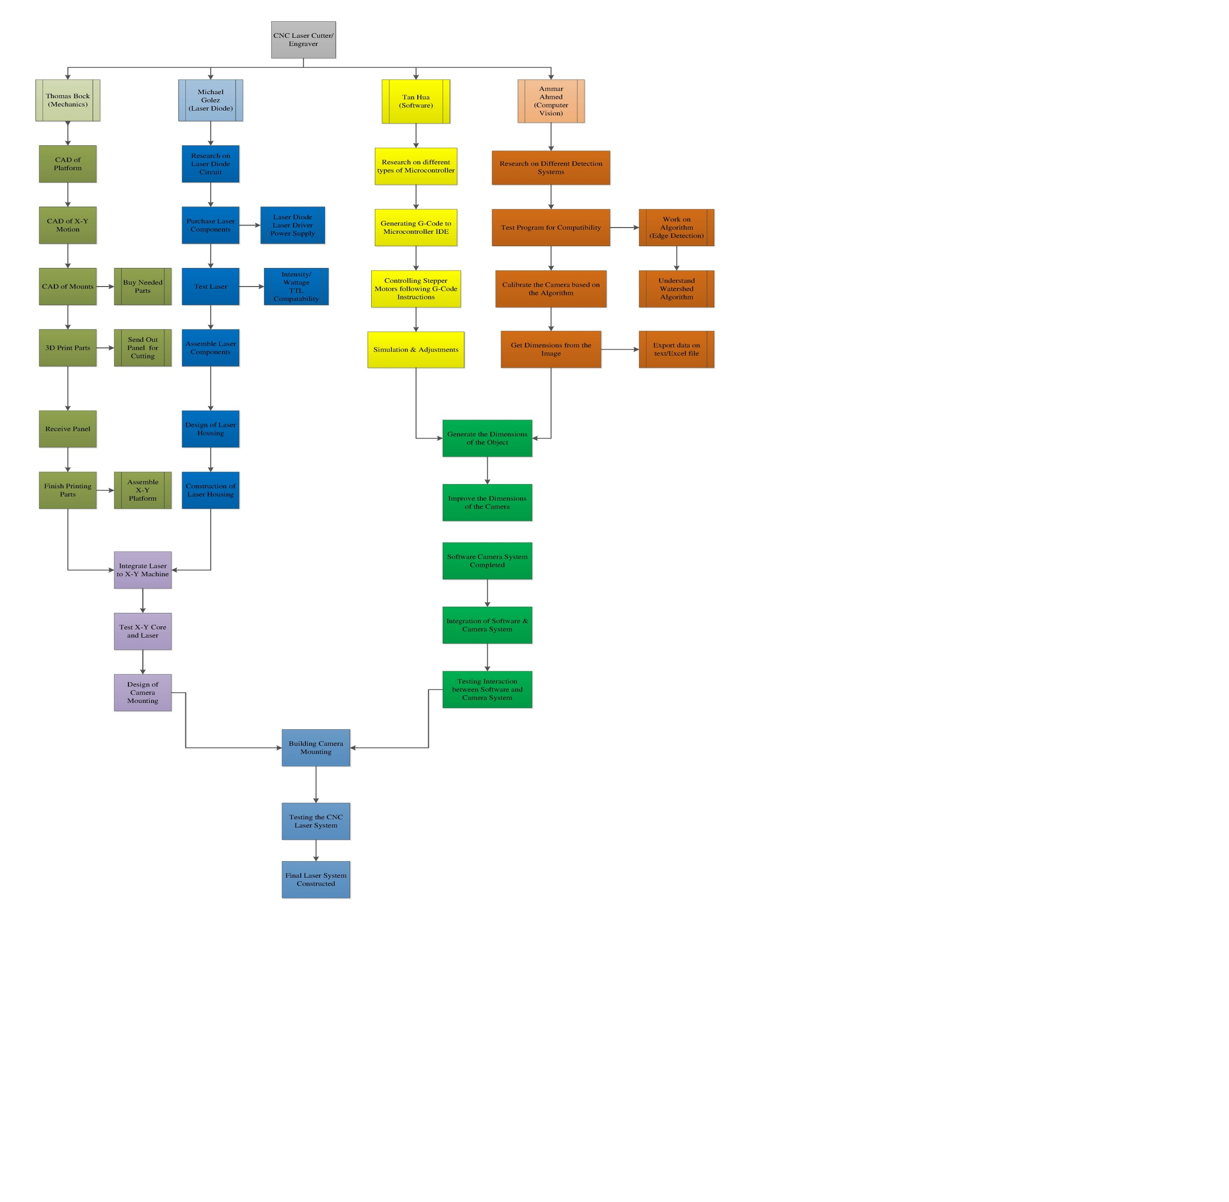

Figure WBS

### Mechanics (#TODO (TOM))

The mechanical portion of the laser system consisted of two basic structures. The first phase focused on the primary design of the structure. The design had many drafts until a final design was constructed. Once the design was made, the next phase required integration of the system into two different phases. The first phase was mechanical/hardware integration. Once integration of the hardware with the mechanics was done, final integration with software proceeded.

### Laser Diode (#TODO (MIKE))

The hardware section of the laser system consisted of two basic structures. The first phase focused on the primary limit of the current. The first design was a limiting circuit that can drive a constant current source of 1.5A towards the laser diode. Future possibilities of laser diode drive were considered. The second phase revolved around the integration of the mechanics with the laser diode. The position was vital so that when the motors rotate the laser can reach its desires value.

### Software (#TODO (Tan))

The software section of this project consisted of two main phases: choosing compatible equipment and integrate with other parts of system. We successfully chose the according equipment, then proceeded to integrate with others during spring break and last few weeks before final presentation and demonstration.

### Computer Vision (#TODO (Ammar)= Updated)

The computer vision section of this project consisted of three main phases: detect the object, determine its location, and determine its dimensions before integration. We successfully finished all phases by the end of the semester. The computer vision has been transferred from MATLAB (Last semester) to OpenCV-python which was installed on RaspberryPi 3.

## Project Timeline (#TODO (Mike))

Asides having a Work Breakdown Structure, to organize the components of the project a Gant Chart was produced to represent the timing of the tasks required. The timing chart creates a projection of each activity and its duration an overlap and intersection of each individual part, and finally a description of each individual part. Below will be an illustration of the Project Timeline for the first half of project design. However, for detailed information, the reference displays the task assigned in the reference and projection completion date.

### Milestone 1

In the first milestone, each individual was tasked with researching their individual parts such as: mechanics, laser system, software, and computer vision. Also, each member is responsible to have their individual parts to be functionally working and prepared for upcoming integration.

### Milestone 2

The second milestone assigned each member to integrate their respective parts. For example, the integration of the hardware along with the mechanics, while at the same time integration of software and computer vision should be done by the second month. This projection accounts for technical issues that might arise within the integration of both systems.

### Milestone 3

The third milestone required that a full integration of the laser system be finished by the last month. This integration gives the design group to finalize the project in order to create a more aesthetic product that operational. By achieving this milestone the design group can showcase the final prototype during presentation, and give a demonstration of it ability and usefulness toward society itself.

# Risk Assessment

## Laser Emission Hazard

Upon operating the 2W 445nm Blue Laser Diode the photonic beam emitted from the diode can severely injure the retina of the eye. Because the laser diode operates at a wavelength of 445nm, safety goggles are used to shield the eyes from this wavelength. Also, because the wavelength of the laser diode is dangerous to everyone who doesn’t have eye protection, the operation of the laser must be at a secluded location. This seclusion from people prevents unwanted injuries that can occur from accidental observation of the laser diode while operating.

## Smoke Hazard

During Operation of laser system, the burning/engraving of materials creates a pool of smoke on the workspace. In order to account for accumulation of smoke near the workspace and on the laser diode, an external fan was used to ventilate the smoke. By using an external fan, the smoke was ventilated from the workspace preventing any buildup which can trigger a fire alarm, damage the diode, or harmful inhalation through the human body.

## Fire Hazard

The last accountable factor that can affect the safety of those around the laser cutter/engraver is a fire hazard. While the device is operating thermal eunwat on the laser driver and mechanical machine can cause the system to ignite. However, in order to account for these incidents temperature control is built into the hardware devices to regulate the temperature. Also, to further prevent any casualties that can occur upon operating the laser machine, a design group member must be present upon operating the machine.

# User Manual (#TODO: Tan)

## Safety Requirement

* Closed room
* Goggles

## Hardware Requirement

* Computer
* Power Supply
* On/Off switch

## Software Requirement

* MATLAB
* Inkscape
* Repetier Host

## Operation

Step 1. Place the object on workspace

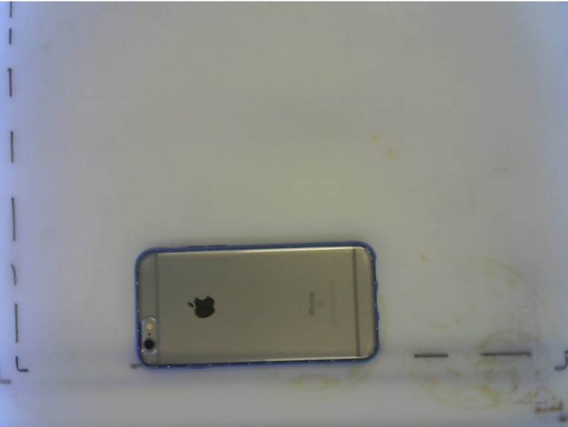

Figure Step 1

Step 2. Run the code from the touchscree to obtain location and dimensions of the object



Figure Step 2

Step 3. Place the design on Inkscape accordingly

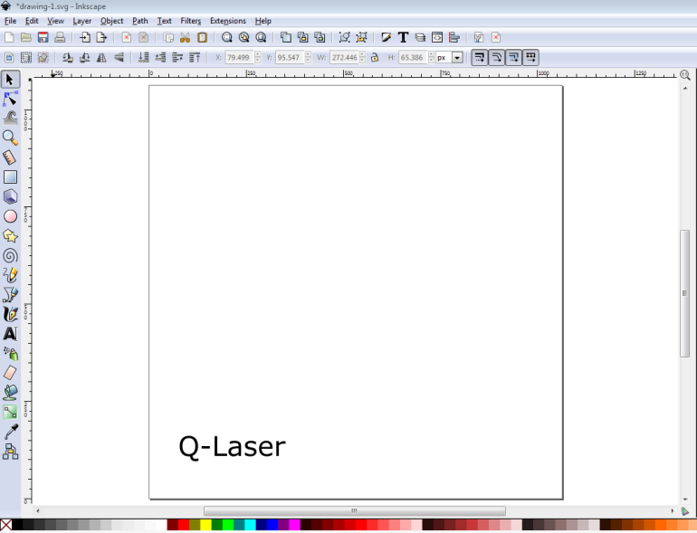

Figure Step 3

Step 4. Using Q-Laser plugin to generate G-code instruction

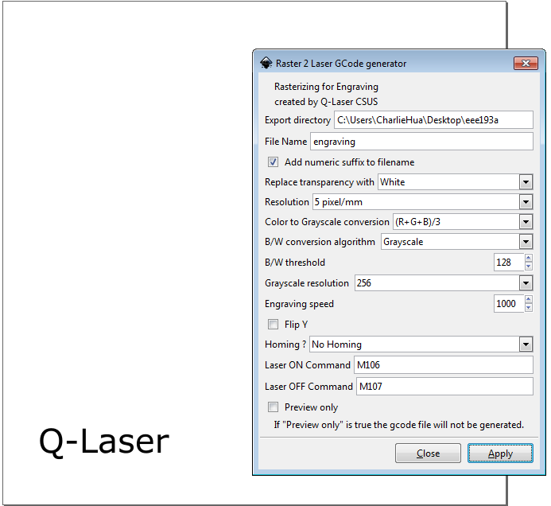

Figure Step 4

Step 5. Using Repetier Host to preview and click print to start the process

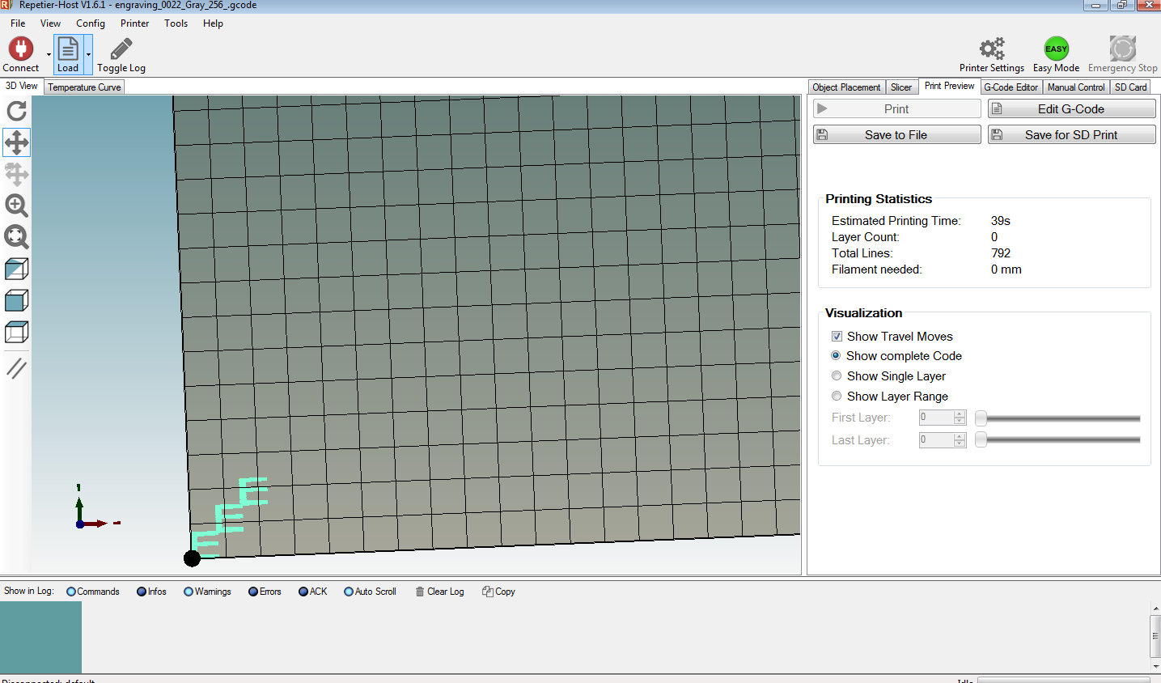

Figure Step 5

# Design Documentation

## Hardware Subsystems (#TODO (Tom))

### Camera

First hardware component that begins the process is the camera. In our project, we use Raspberry Pi Camera Module v2 because of its great compatibility with the RaspberryPi 3. It is used to capture the object that is placed on the workspace and obtain the object dimensions.

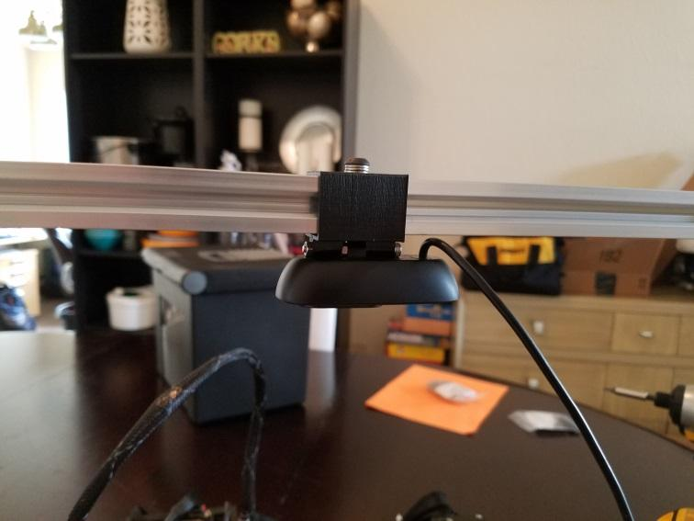

Figure

### Laser Diode (#TODO (Mike))

The operational function of the laser system will be solely dependent upon the microcontroller and laser driver attached towards the laser diode. A simple laser diode will conduct a high-energy beam that can cut or engrave a material prior to user command. However, both the microcontroller and laser driver will work on conjunction with each other. The overall purpose of the laser driver is to deliver a constant current source towards the laser diode in order for the system to operate at a particular application. However, regulating the intensity and precision of the engraving/cutting required the alteration of PWM. A controller is needed to vary the output of the laser so that upon engraving/cutting a material of interest it becomes precise and accurate to the desired requirement.

In order for the laser diode to function operationally, different types of drivers were tested and applied towards the laser diode:

* 1. 1.8 X-Drive V6 Laser Driver:

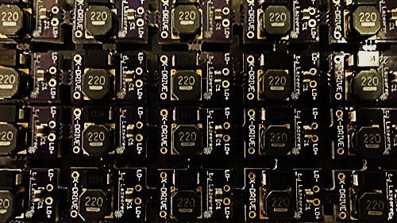

Figure

The 1.8X-Drive V6 Laser Driver was the first chosen laser driver to operate the laser diode. The reasoning for combining both the laser diode and X-Drive was the compatibility factor of the circuit with the 2W 445nm M140 Blue Diode. Further review listed from the vendor guaranteed that the driver has low noise capabilities along with self-bleeding caps to prevent spikes created by charged output caps. The circuit component became unnecessary because upon further inspection TTL was not compatible with the device. Another version known as the 4A Super X-Drive Laser Driver was considered, but upon inspection compatibility was not successful with the laser diode.

* 1. 12V TTL 200mW to 3W 445nm 450nm Laser Diode LD Power Supply Driver :

|  |  |
| --- | --- |
| Figure | Figure |

The 12V TTL 200mW to 3W 445nm 450nm Laser Diode (LD) Power Supply Driver replaced the X-drive because of its TTL capabilities. This circuit module provides both a current and voltage regulation towards the load, thus setting a constant source towards the laser diode. By having the user alter the output voltage and limit the current, the laser diode can operate within the region of operation. After setting the limit source, the TTL modulation can then vary the power of the laser by altering the PWM. The 12V TTL 200mW-3W Laser Diode Power Supply Driver was the main current driver used to power the laser until Compliant Laser Driver was purchased

* 1. 2.5 Amp Adjustable Safety Compliant Laser Diode Driver Kit, for UV-Blue diodes, with International Power Adapter:

|  |  |
| --- | --- |
|  |  |
|  |  |

The Compliant Laser Diode Driver replaced the previous drivers because of software compatibility and hardware features. Although the Compliant Laser Driver provides the same the capabilities as the 12V TTL Power Supply Driver, it also differed in many ways. One advantage the compliant laser driver provided was software compatibility with the Software programs such as: Matlab, InkScape, and Repetier Host.

### Microcontroller and Shield

Microcontroller is the core of the hardware system. In this project, we use Arduino MEGA 2560 to control the stepper motors for core x-y movement, laser driver for laser intensity and so on. Moreover, in order to maximize the efficiency, we use stepper motor driver shield RAMPS 1.4 on top of the Arduino MEGA 2560, which is commonly used for 3-D printing applications.

### Block Diagram (#TODO (Mike))

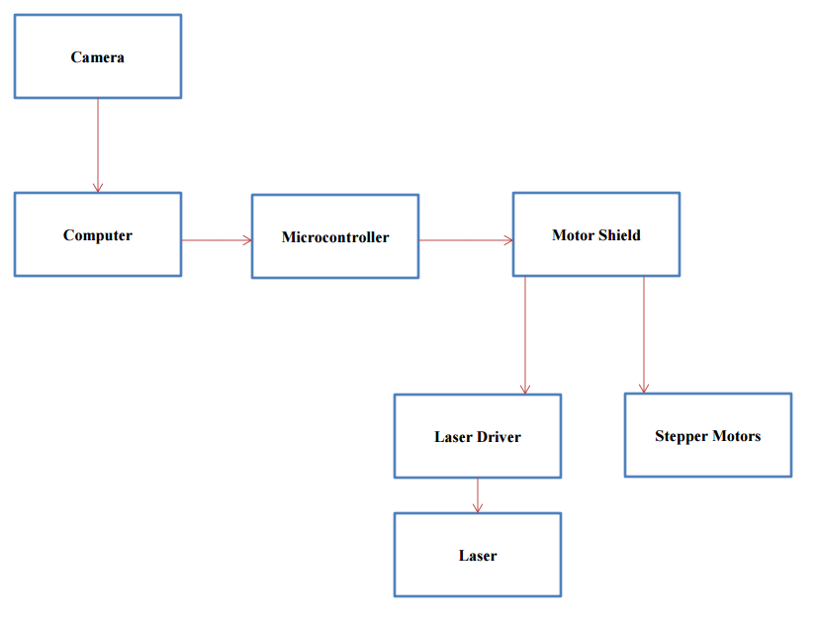

Figure Hardware Block Diagram

## Software Subsystems (#TODO (Tan))

### Object Detection Algorithm

Using OpenCV-python with a lot of useful built-in functions and libraries, the location and dimensions of any object can be measured and sent to Octoprint.

### Design and G-Code Generator

After obtaining the location and dimensions of the object from OpenCV-python algorithm, location coordinates along with width and height of the object will be input in Inkscape. Then, the desired design will be placed accordingly on the object location we determine before. Then G-code instruction will be generated through Q-Laser plugin.

### Stepper Motor and Laser Control

G-code instruction will be placed in Repetier Host software, and it will execute these instructions as it describes to obtain the physical product.

### Flowchart

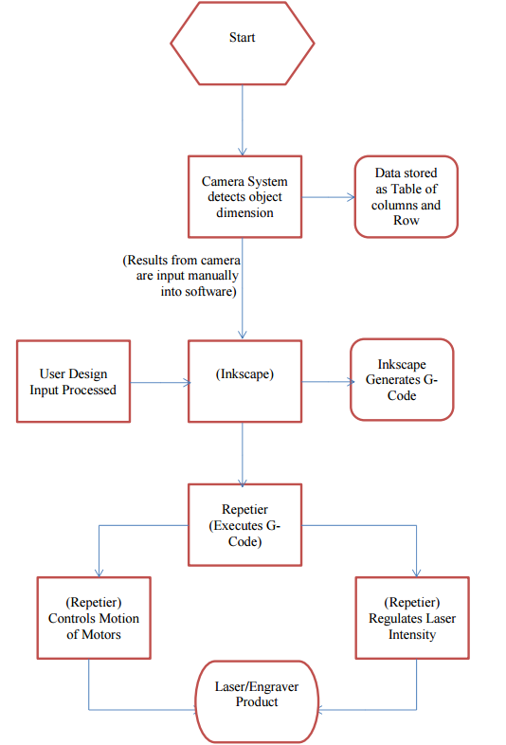

Figure Software Flowchart

# Test Plan

## Hardware

### 3D Printed Parts

* Check dimensions
* Check rigidity
* Add mounting hardware
* Test for looseness

### Linear Motion Parts

* Check rods for straightness
* Grease bearings
* Test bearings for smoothness

### Frame

* Assemble frame
* Check squareness
* Check rigidity

### Assembly

* Assemble Frame
* Add 3d printed parts
* Add linear motion parts
* Add nuts and bolts
* Check dimensions
* Check for cracks
* Add and tighten belts
* Check for binding

### Laser

* Laser diode driver
* Output Power
* Intensity level
* Frequency

## Software

### Microcontroller Test

* ZeroPi from Kickstarter
* Arduino Uno 3 and Smart Stepper Driver
* Arduino Mega 2560 + RAMPS 1.4

### Software Test

* Operating System
* Inkscape
* Plugin
* Repetier Host

### Computer Vision

* Object Detection
* Object Location
* Object Dimensions
* Communicating with Octoprint

## Integration

The majority of the project was integrated over the spring break. This is when the final assembly of the mechanical parts occurred and the laser parts were mounted to the mechanics. The firmware for the microcontrollers was installed at this point and several hours worth of work went into modifying the firmware to run the movement of the laser cutter. At this point we were able to finally test out the mechanics and see the toolhead move.

# Accomplishment and Improvement Ideas

## Accomplishment

* Machine is fully operational
* Cost is under budget
* Minimum size requirements are met

## Improvement Ideas

* Filtration System
* Machine Enclosure
* Improve Engraving Algorithm
* Improve camera accuracy in measurements
* Automatic communication between camera system and software.

# Conclusion

In conclusion, the design group was able to implement their knowledge of their core electrical engineering focus to create a low cost, laser system. They were able to construct a product that can be used to create/engrave a material for educational or hobby purposes.

# Appendix A: Reference

* <http://corexy.com/>
* <http://jtechphotonics.com/>
* <http://reprap.org/wiki/RAMPS_1.4>
* <https://www.repetier.com/>
* <http://openbuilds.com/>

# Appendix B:

## Project Timeline

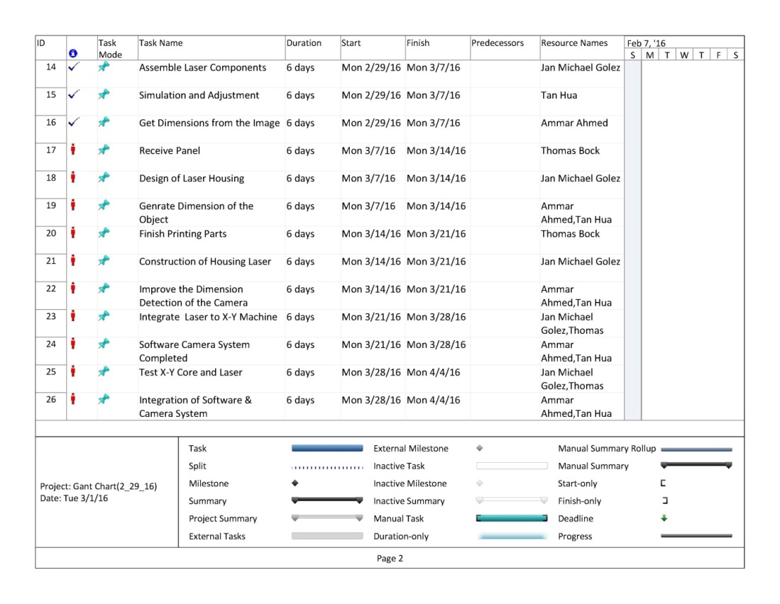

Figure Project TImeline

## Code (#TODO Tan)

Portion of XML file of the plugin interface. The remaining is provided in our website.

<?xml version="1.0" encoding="UTF-8"?>

<!-- Comment -->

<!--  -->

<inkscape-extension xmlns="http://www.inkscape.org/namespace/inkscape/extension">

<name>GCode generator</name>

<!-- il campo ID deve essere univoco  -->

<id>com.305engineering.raster2laser_gcode</id>

<!-- Dipendenze, basta solo lo script python principale -->

<dependency type="executable" location="extensions">raster2laser_gcode.py</dependency>

<dependency type="executable" location="extensions">inkex.py</dependency>

<!-- Nome con cui compare l'estensione nel menù, fa casino con gli underscore _ -->

<!-- Parametri di input per lo script python che vengono visualizzati nel widget creato da inkscape-->

<!-- vengono generati in ordine di come vengono scritti  -->

<!-- Titolo e descrizione -->

<param name="Title" type="description">Rasterizing for Engraving</param>

<param name="Description" type="description">created by Q-Laser CSUS</param>

<!-- Opzioni di esportazione dell'immagine -->

<param name="directory" type="string"  gui-text="Export directory"></param>

<param name="filename" type="string"  gui-text="File Name"></param>

<param name="add-numeric-suffix-to-filename" type="boolean" gui-text="Add numeric suffix to filename">true</param>

<param name="bg_color" type="enum" gui-text="Replace transparency with">

<_item value="#ffffff">White</_item>

<_item value="#000000">Black</_item>

</param>

<param name="resolution" type="enum" gui-text="Resolution">

<_item value="1">1 pixel/mm</_item>

<_item value="2">2 pixel/mm</_item>

<_item value="5">5 pixel/mm</_item>

<_item value="10">10 pixel/mm</_item>

</param>

<!-- Come convertire in scala di grigi -->

<param name="grayscale_type" type="enum" gui-text="Color to Grayscale conversion">

<_item value="1">0.21R + 0.71G + 0.07B</_item>

<_item value="2">(R+G+B)/3</_item>

<_item value="3">R</_item>

<_item value="4">G</_item>

<_item value="5">B</_item>

<_item value="6">Max Color</_item>

<_item value="7">Min Color</_item>

</param>

<!-- Modalità di conversione in Bianco e Nero -->

<param name="conversion_type" type="enum" gui-text="B/W conversion algorithm ">

<_item value="1">B/W fixed threshold</_item>

<_item value="2">B/W random threshold</_item>

<_item value="3">Halftone</_item>

<_item value="4">Halftone row</_item>

<_item value="5">Halftone column</_item>

<_item value="6">Grayscale</_item>

</param>